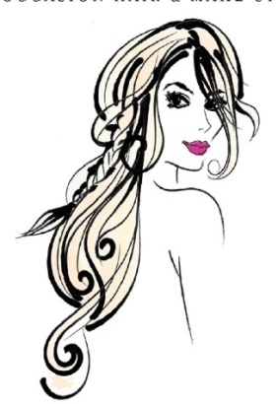
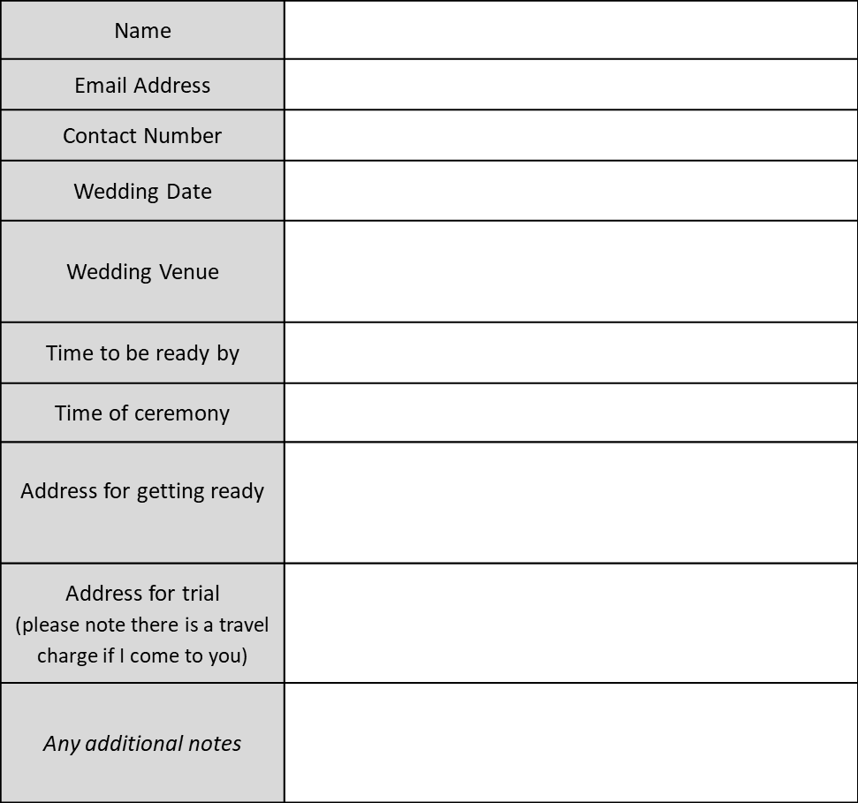
CHARLOTTE CHARTELL
OCCASION HAIR AND MAKE-UP
www.charlottec.co.ukcharlottechartellhairmakeup@mail.com 07929988772
Booking Form (2025)
Bride | Wedding Day Hair AND Make-Up | £140
 | Wedding Day Hair Up/Styling | £85
 | Wedding Day Make-Up | £85
 | Trial Hair AND Make-Up (up to 2 hours) | £65
 | Trial Hair OR Make-Up (up to 1 hour) | £45
Mother of the Bride/Groom ……  Bridesmaids ……  Please state numbers of each | Wedding Day Hair AND Make-Up | £100
 | Wedding Day Hair Up/Styling | £65
 | Wedding Day Make-Up | £65
 | Trial Hair AND Make-Up (up to 2 hours) | £55
 | Trial Hair OR Make-Up (up to 1 hour) | £40
Young Bridesmaids (10-16) | Wedding Day Hair AND Make-Up | £65
 | Wedding Day Hair Up/Styling | £40
 | Wedding Day Make-Up | £40
 | Trial Hair AND Make-Up (up to 1 hour) | £30
 | Trial Hair OR Make-Up (up to 30 mins) | £25
Flower Girls  Services Required (please number quantity of each)  (Under 10) | Hair Up/Styling on Wedding Day | £25
 | Glitter and Gloss | FREE
 | Trial Hair (up to 20 mins) | £20
Terms and Conditions
Deposit
A £50 non-refundable deposit is required to secure your date; the balance payment can be made at any time up to 24 hours before the wedding date via BACS or in cash on the day.

Payments
Both trial and wedding day costs must be paid in advance, either by cash before the service begins or via BACs:

Bank Details
Name Mrs Charlotte P Chartell
Sort Code 07-01-16
Account Number 31354093

Cancellations

Saturdays in Peak Season (April-October)
Please note there is a minimum spend of £250 for weddings booked on Saturdays in peak season.

Trials
Trials must be paid for in advance via BACS or on the day in cash.
Trial times are as stated on the booking form pricing above, any additional time over these is charged at £10/hour.

Travel
Travel within 10 miles of Towcester, NN12 6JJ is included. Travel cost for weddings/trials outside of this area are additional. Weddings/trials more than 30 miles of NN12 6JJ may be considered for a larger travel fee and based on a minimum spend. Please get in contact to ask for a travel quote.

