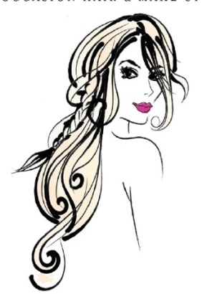
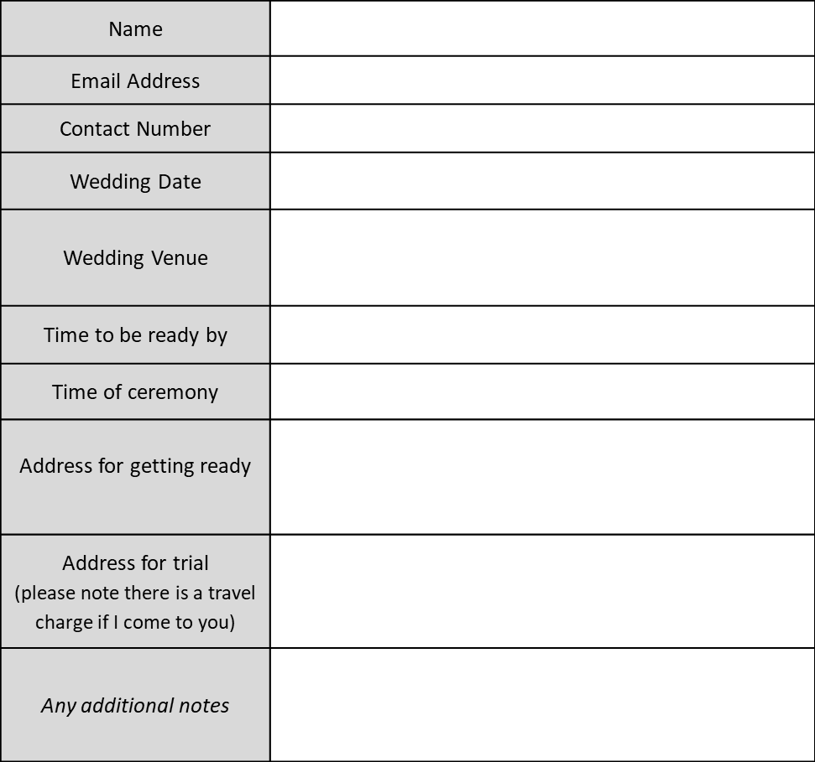
CHARLOTTE CHARTELL
OCCASION HAIR AND MAKE-UP
Booking Form (2027)
Bride | Wedding Day Hair AND Make-Up | £150
Bride | Wedding Day Hair Up/Styling | £95
Bride | Wedding Day Make-Up | £95
Bride | Trial Hair AND Make-Up (up to 2 hours) | £75
Bride | Trial Hair OR Make-Up (up to 1 hour) | £55
Mother of the Bride/Groom ……  Bridesmaids ……  Please state numbers of each | Wedding Day Hair AND Make-Up | £110
 | Wedding Day Hair Up/Styling | £75
 | Wedding Day Make-Up | £75
 | Trial Hair AND Make-Up (up to 2 hours) | £65
 | Trial Hair OR Make-Up (up to 1 hour) | £50
Young Bridesmaids (10-16) | Wedding Day Hair AND Make-Up | £75
Young Bridesmaids (10-16) | Wedding Day Hair Up/Styling | £50
Young Bridesmaids (10-16) | Wedding Day Make-Up | £50
Young Bridesmaids (10-16) | Trial Hair AND Make-Up (up to 1 hour) | £40
Young Bridesmaids (10-16) | Trial Hair OR Make-Up (up to 30 mins) | £35
Flower Girls  Services Required (please number quantity of each)  (Under 10) | Hair Up/Styling on Wedding Day | £35
 | Glitter and Gloss | FREE
 | Trial Hair (up to 20 mins) | £25
Terms and Conditions

Deposit
A £50 non-refundable deposit is required to secure your date; the balance payment can be made at any time up to 24 hours before the wedding date via BACS or in cash on the day.

Contract
This booking form, combined with the deposit is a contractual agreement for the booking, please read the cancellation terms before signing.

Payments
Both trial and wedding day costs must be paid in advance, either by cash before the service begins or via BACs:

Bank Details
Name Mrs Charlotte P Chartell
Sort Code 07-01-16
Account Number 31354093

Cancellations
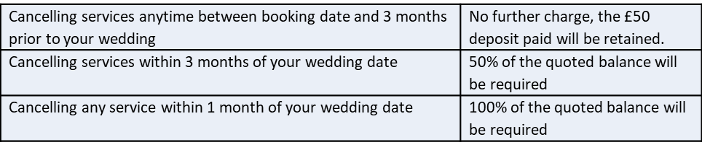

Saturdays in Peak Season (April-October)
Please note there is a minimum spend of £250 for weddings booked on Saturdays in peak season.

Trials
Trials must be paid for in advance via BACS or on the day in cash.
Trial times are as stated on the booking form pricing above, any additional time over these is charged at £10/hour.

Travel
Travel within 5 miles of Towcester, NN12 6JJ is included. Travel cost for weddings/trials outside of this area are additional. Weddings/trials more than 30 miles of NN12 6JJ may be considered for a larger travel fee and based on a minimum spend. Please get in contact to ask for a travel quote.

Signature
By signing below the Client acknowledges that they have read, understood, and agree to abide by the terms and conditions outlined in this agreement. This contract represents the entire agreement between both parties and is binding upon signature. By signing, the Client confirms acceptance of all services, policies, and payment terms detailed above.

Client Signature: _______Mrs Smith___________

Date: ____ 01/01/26 ___________

